The ANCs present their positions and recommendations on issues to various District government agencies, the Executive Branch, and the Council. They also present testimony to independent agencies, boards, and commissions, usually under the rules of procedure specific to those entities. By law, ANCs may present their positions to Federal agencies. Among the most common cases of ANC involvement are the review of liquor licenses and cases before the Board of Zoning Adjustment and Zoning Commission.

**ANC Structure**

There are 46 ANCs. Each ANC area is subdivided into smaller areas known as Single Member Districts (SMDs) represented by a single commissioner. Although each SMD represents about 2,000 people, ANCs may vary widely in the number of SMDs per ANC. Currently, ANCs have between two and ten SMDs. As a result of the population growth shown in the most recent census, the number of SMDs increased to 345.

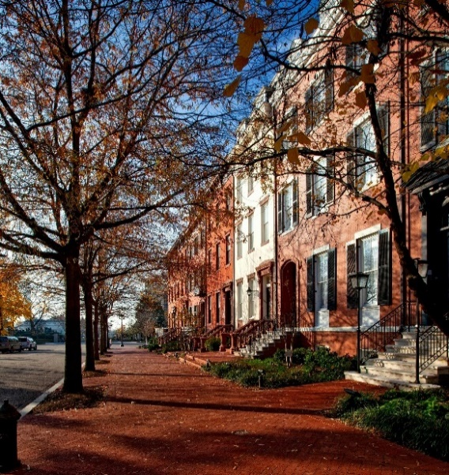



**Lookup Your ANC with the QR Code**



**WHAT’S AN ADVISORY NEIGHBORHOOD COMMISSION (ANC)?**

**ADVISORY NEIGHBORHOOD COMMISSIONS**

Advisory Neighborhood Commissions (ANCs) are bodies of [local government](https://en.wikipedia.org/wiki/Local_government_in_the_United_States) in the [District of Columbia](https://en.wikipedia.org/wiki/District_of_Columbia). The ANC system was created in 1974 in the [District of Columbia Home Rule Act](https://en.wikipedia.org/wiki/District_of_Columbia_Home_Rule_Act). The first elections for Advisory Neighborhood Commissioners were held in the fall of 1975, and commissions began operating in 1976.

Each ANC is a non-partisan, neighborhood body made up of locally elected representatives called Advisory Neighborhood Commissioners. Commissioners are elected to serve two-year terms and serve without pay. They are elected in November of even-numbered years (e.g., 2022).

**Duties and Responsibilities**

The ANCs were established to bring government closer to the people and to bring the people closer to government. To do this, time is required to be set aside in each public meeting to hear community comments.

The roles and responsibilities of ANCs are enumerated by the DC Code § 1–207.38:

1. 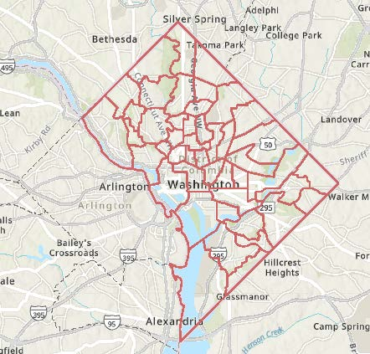May advise the District government on matters of public policy including decisions regarding planning, streets, recreation, social services programs, health, safety, and sanitation in that neighborhood commission area;
2. May employ staff and expend, for public purposes within its neighborhood commission area, public funds and other funds donated to it; and
3. Shall have such other powers and duties as may be provided by act of the Council.

**Map outlining the 46 ANC areas in the District of Columbia.**

The ANCs’ main job is to be their neighborhood’s official voice in advising the District government on events that affect their neighborhoods. Although they are not required to follow the ANCs’ advice, District agencies are required to give the ANCs’ recommendations “great weight.” Moreover, District law states that agencies cannot take any action that will significantly affect a neighborhood unless they provide the affected ANCs with 30 days' advance notice. This includes zoning, streets, recreation, education, social services, sanitation, planning, safety, budget, and health services.

The ANCs may also initiate recommendations for improving city services, conduct neighborhood improvement programs, and monitor resident complaints. Each agency of the District of Columbia is required to have a liaison whom ANC Commissioners can contact directly about issues that agency can address.