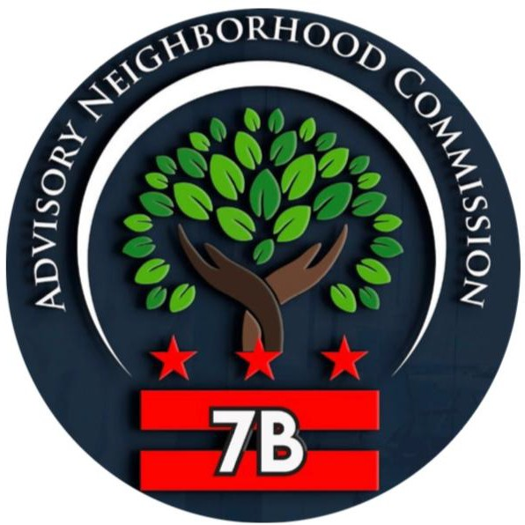

Commissioners

John F. Adams
Vice Chairperson
7B01

J. Maurice Pearsall
7B02

Travis R. Swanson
Chairperson
7B03

Keith Hasan-Towery
Treasurer
7B04

Elizabeth Reddick
Sergeant at Arms
7B05

Cortez Johnson
7B06

Jimmie Williams
7B07

Angela Sydnor
7B08

Michelle Hammond
Secretary
7B09

Find Your SMD

tinyurl.com/FindMySMD

Advisory Neighborhood Commission 7B
Proudly Serving the Dupont Park, Fairfax Village, Fairlawn, Fort Davis, Greenway, Hillcrest, Naylor Gardens, Penn Branch, Randle Highlands, and Twining Communities

Community Meeting Agenda
Thursday, January 15, 2026 | 6:30 p.m.
Joy Evans Therapeutic Recreation Center | 3030 G Street SE or Join online via Zoom - tinyurl.com/ANC7B2025

6:30 pm Call to Order 6:30 pm Roll Call
6:35 pm Election of 2026 Officers (10 mins)

6:45 pm Consent Agenda (5 mins)
- November 20, 2025 Meeting Minutes
- 2026 Meeting Schedule
- 2025 Q4 QFR
- Letter opposing removal of proposed park space at Phase III of the Skyland Town Center development project
6:50 pm Treasurer’s Update (15 mins)
- ANC 7B 2026 Budget

7:05 pm Standing Updates (30 mins)
- Office of Mayor Muriel Bowser (10 mins)
Office of Councilmember Wendell Felder (10 mins)
- Metropolitan Police Department (10 mins)

7:35 pm New Business (20 mins)
- BZA 21410 (2324 Nicholson St SE)

7:55 pm Community Concerns (25 mins)

8:20 pm Community Announcements (10 min)
- Join a Committee!

8:30 pm Adjourn

